OFFICIAL COORDINATION REQUEST FOR
NON-ROUTINE OPERATIONS AND MAINTENANCE

COORDINATION TITLE- 17BON03 Cascade Island Entrance Pool Repairs
COORDINATION DATE- 23 February 2017
PROJECT- Bonneville
RESPONSE DATE- 2 March 2107

Description of the problem

On 07 February, Project biologists conducted an ROV inspection of the Cascade Island (CI) and B-branch entrance pools. No issues were found at B-branch. Four items of concern were found at CI (see Figure 1 for diffuser locations):

- A diffuser pit access hatch across from FG6-18 is displaced, leaving an opening into the diffuser pit.
- A piece of grating at FG6-20 is blown off, leaving an opening into the diffuser pit.
- One of two channel keeper bars on the FG6-16 diffuser plate is blown off. These bars hold the diffuser plate in place. When the other bar goes, the diffuser plate will displace leaving an opening to the diffuser pit below.
- The south elevator door has a screened opening at its base that is blown open.

Openings to diffuser pits may attract fish with flow when the diffuser is open. Currently, diffusers FG6-18, FG6-19 and FG6-20 are being kept closed, so that there is no attraction flow to that area. Diffusers FG6-16 and FG6-17 are the only diffusers feeding the entrance bay, leading to a reduced flow. While there is a potential for this to drop the entrance differentials out of FPP criteria, after several days of operating with this configuration flows have stayed within their mandated range. The valve feeding these diffusers is also being run in manual, at a reduced flow, in order to reduce the chance of blowing out more diffuser gratings or the already compromised diffuser plate at FG6-16.

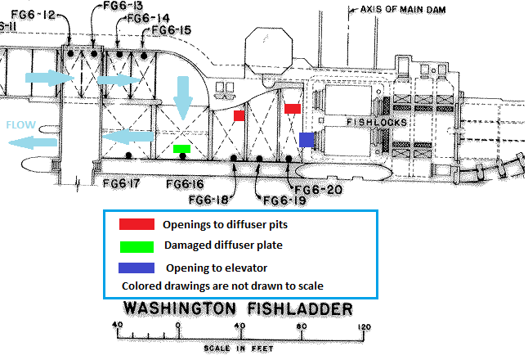
Figure 1. Overhead view of the Cascades Island Entrance Bay and impacted areas.

The current options are:

- No action. Wait until the next scheduled dewatering of the ladder during winter of 2018/19 to make the fixes. This entails leaving diffusers FG6-18, FG6-19 and FG6-20 closed, and reprogramming the system to use other diffusers to adjust. The project believes this is a viable option and that ladder criteria could be maintained with minimal impact.

- Dewater and fix in early March. This would entail a full dewatering of the CI ladder and Entrance Bay for a week of work, with an estimated cost of ~$30,000-35,000.

Type of outage required

- No outage.
- Fixing in March would require dewatering the CI ladder and entrance for four days (06 – 09 March).

Impact on facility operation (FPP deviations)

- Above tailwaters of 12’, 15’, and 19’ msl; diffusers FG6-18, -19, and -20 are supposed to be open, respectively. Alternate diffusers could be programmed to operate in their place to maintain the entrance differential.
- The CI ladder would be out of service for four days (06 – 09 March). Spill bay 01 would be placed on sill during this time to negate attraction flow.

Impact on unit priority

None.

Impact on forebay/tailwater operation

None.

Impact on spill

Attraction flow for the Cascades Island entrance will be closed for the duration of the work and 0.5 to 1.5 kcfs shifted to spill elsewhere along the spillway.

Dates of impacts/repairs

The proposed work would go from 06 to 09 March. Due to limited crew availability, this would require delaying the reinstallation of the spillway and corner collector avian lines removed for the BI erosion repair work (16BON107), and the replacement of powerhouse tailrace lines that were broken during the January ice storm. Avian line installation would occur after the CI ladder dewatering, starting on 13 March.

Length of time for repairs

Four days.

Analysis of potential impacts to fish
Adult salmonids

Impacts to upstream-migrating salmonids are expected to be minimal. The 10-year average for numbers of adult salmonids passing Bonneville from 06 – 09 March is given in Table 1.

-With a 10 year average of 766,947.9 Chinook per year, the average number of Chinook passing Bonneville from 06 – 09 March constitutes 0.0000149 % of the total Chinook run.

-With a 10 year average of 332,638 Steelhead per year, the average number of Steelhead passing Bonneville from 06 – 09 March constitutes 0.000398% of the total Steelhead run.

 | Chin | JChin | Stlhd | WStlhd | Coho
6-Mar | 2.2 | 0 | 38.7 | 17.8 | 0
7-Mar | 3.2 | 0.1 | 35.5 | 11.6 | 0
8-Mar | 2 | 0 | 27.6 | 9.3 | 0
9-Mar | 4.1 | 0.2 | 31.4 | 10.5 | 0
Total | 11.5 | 0.3 | 133.2 | 49.2 | 0

Table 1. Ten year averages for fish passage at Bonneville during the proposed work period. These averages include both the Washington Shore and Bradford Island ladders.

According to NOAA, this year's Spring Chinook run is forecast to be at or below average. From 01 January to 15 February, Bonneville passed 1 Chinook and 99 Steelhead in 2017, compared to 10 year averages of 2.3 and 568, respectively. Additionally, Spill bay 01 will be on sill during this operation to limit attraction flow to the CI entrance. B-branch is scheduled to be returned to service by the proposed work window, providing a passage route at the other end of the Spillway. Delay to migrating adults should therefore be minimized.

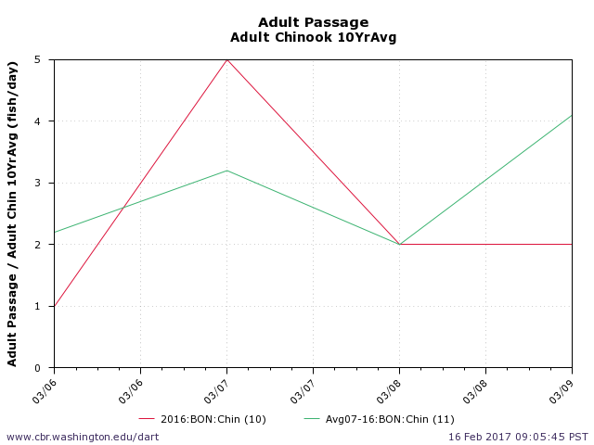
Figure 2. 10 year average of adult Chinook passage at Bonneville during the proposed work period.
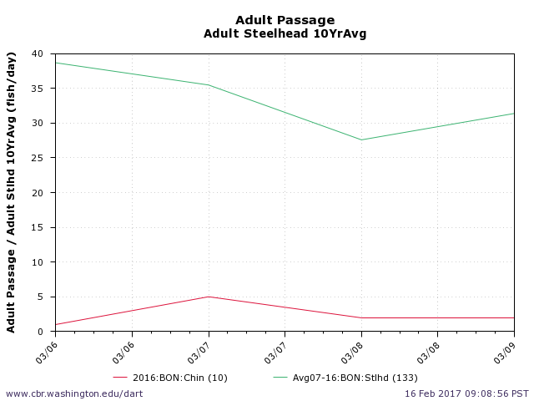
Figure 3. 10 year average of adult Steelhead passage at Bonneville during the proposed work period.

Juvenile salmonids

Negligible impact. The Cascades Island ladder is not a major downstream migration route for juveniles.

Summary statement - expected impacts on:

Downstream migrants- None

Upstream migrants (including Bull Trout) - Negligible

Lamprey- None

Comments from agencies
-----Original Message-----
From: Tom Lorz [mailto:lort@critfc.org]
Sent: Monday, February 27, 2017 11:35 AM
To: Kovalchuk, Erin H CIV USARMY CENWP (US) <Erin.H.Kovalchuk@usace.army.mil>
Cc: gary.fredricks@noaa.gov
Subject: [EXTERNAL] Re: FPOM: Official Coordination 17BON03 MOC CI Entrance Repairs

Taking a look at the MOC and following the gary email saga I will stick with my original recommendation that we should just plan on getting the work done this year, especially since CI is not going down next year, 2 years might be a little too long to wait on this stuff, and it would be good to get some eyeballs on these areas to determine their overall condition incase we need to be prepared to do more extensive work in 2 years.

thanks

tom lorz
CRITFC

-----Original Message-----
From: Gary Fredricks - NOAA Federal [mailto:gary.fredricks@noaa.gov]
Sent: Monday, February 27, 2017 11:08 AM
To: Derugin, Andrew G CIV CENWP CENWD (US) <Andrew.G.Derugin@usace.army.mil>
Cc: Kovalchuk, Erin H CIV USARMY CENWP (US) <Erin.H.Kovalchuk@usace.army.mil>; Subject: Re: [EXTERNAL] Re: FPOM: Official Coordination 17BON03 MOC CI Entrance Repairs

Thanks for the response Andrew. I certainly wouldn't want to see this issue go two years, so I guess I'm still in the camp of getting this work done as soon as you guys can.

Gary

On Mon, Feb 27, 2017 at 10:57 AM, Derugin, Andrew G CIV CENWP CENWD (US) <Andrew.G.Derugin@usace.army.mil <mailto:Andrew.G.Derugin@usace.army.mil> > wrote:

Gary,

Just a heads up, CI isn't slated to go down next winter. It would be the following winter of 2018/19.

Dewatering and rewatering the ladder is the majority of the labor costs, so that portion would be absorbed by the general winter maintenance fund, something along the lines of $20-25k. $5-10k for the actual work. I'll take a costs breakdown into consideration for future MOCs..

Andrew

-----Original Message-----
From: Gary Fredricks - NOAA Federal [mailto:gary.fredricks@noaa.gov <mailto:gary.fredricks@noaa.gov> ]
Sent: Monday, February 27, 2017 10:35 AM
To: Derugin, Andrew G CIV CENWP CENWD (US) <Andrew.G.Derugin@usace.army.mil <mailto:Andrew.G.Derugin@usace.army.mil> >
Cc: Kovalchuk, Erin H CIV USARMY CENWP (US) Subject: Re: [EXTERNAL] Re: FPOM: Official Coordination 17BON03 MOC CI Entrance Repairs

Andrew, It is going to cost labor dollars to do this now or next winter. Any idea what the difference is in labor cost between those two options? Thanks, Gary

On Mon, Feb 27, 2017 at 10:24 AM, Derugin, Andrew G CIV CENWP CENWD (US) <Andrew.G.Derugin@usace.army.mil wrote:

Gary,

The cost estimate is basically all labor. Parts will run a few hundred.

Andrew Derugin
Fish Biologist
U.S. Army Corps of Engineers
Bonneville Lock & Dam

-----Original Message-----
From: Gary Fredricks - NOAA Federal [mailto:gary.fredricks@noaa.gov]
Sent: Friday, February 24, 2017 12:38 PM
To: Kovalchuk, Erin H CIV USARMY CENWP (US) <Erin.H.Kovalchuk@usace.army.mil>
Cc: Hausmann, Benjamin J CIV USARMY CENWP (US) <Ben.J.Hausmann@usace.army.mil>; Derugin, Andrew G CIV CENWP CENWD (US) <Andrew.G.Derugin@usace.army.mil>; Lorz, Tom <lort@critfc.org>; Rerecich, Jonathan G CIV USARMY CENWP (US) <Jonathan.G.Rerecich@usace.army.mil>; Trevor Conder <Trevor.Conder@noaa.gov>
Subject: [EXTERNAL] Re: FPOM: Official Coordination 17BON03 MOC CI Entrance Repairs

Erin, As far as I am concerned, these fishway systems are critical and need to be kept in good shape. It seems to me that having all these failures in the CI system in one season is indicative of a pretty rickety system. So, while no action may be a viable option, I think it risks more damage and possibly losing some fish. Fixing the damage is low risk and I recommend getting it done as indicated in early March. I appreciate the time someone took to put together the detailed analysis of impacts. Do you have a itemized breakdown of that $30-35K cost estimate? Thanks, Gary

Final coordination results

After Action update

Please email or call with questions or concerns.
Thank you,
Erin

Erin Kovalchuk
NWP Operations Division Fishery Section
Columbia River Coordination Biologist
Erin.H.Kovalchuk@usace.army.mil

Andrew Derugin
Bonneville Fisheries
Andrew.G.Derugin@usace.army.mil

